# Lab Manual 9

# Subcircuits

## Objectives

To learn and understand the working of sub circuits in the Logic works

## Subcircuits

LogicWorks provides the ability to have a device symbol in a schematic actually represent an arbitrary circuit block. This subcircuit can be used to implement a simulation model for a device of arbitrary complexity. Subcircuits can be nested to any desired depth, so devices containing subcircuits can themselves be used as subcircuits for more complex devices.

## Implementation of Subcircuits in LogicWorks

Step 1: Draw the schematic of the following turn-signal circuit without clocks.

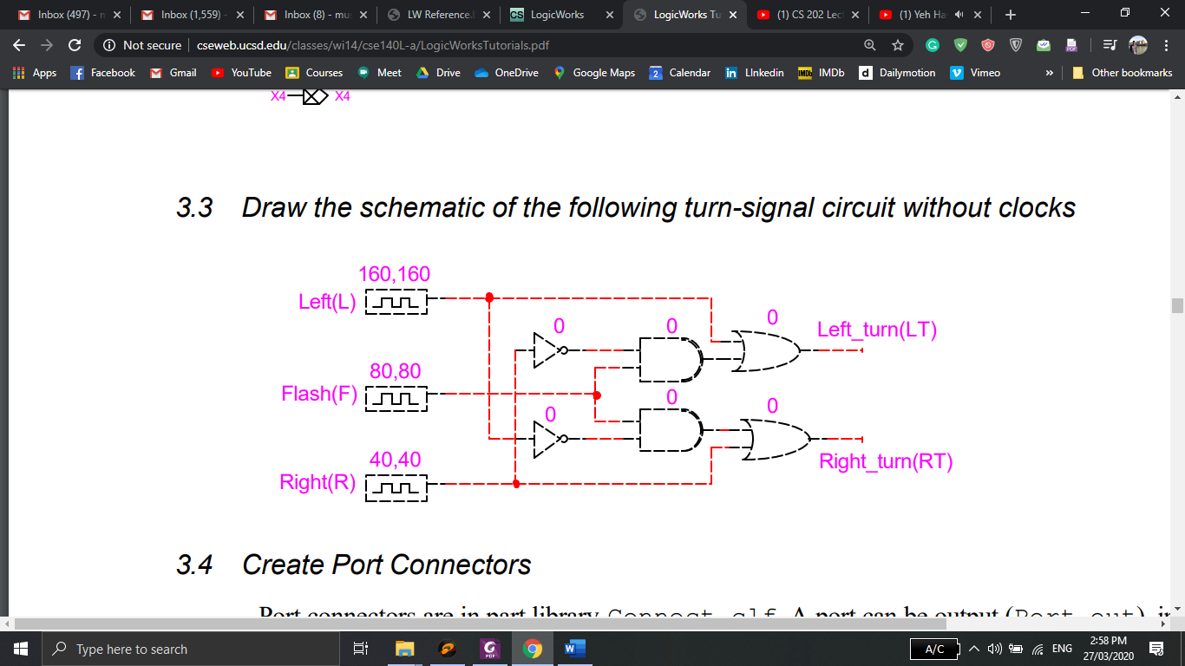

Step 2: Port connectors are in part library **Connect.clf**. A port can be output (**Port out**), input (**Port in**) or bi-directional (**Port Bidir**). A port has port name and signal name. The port name is used to match with its external device pins. The port signal name matches signals in the sub-circuit. For example, in the schematic below, **Left** represent Port signal whereas **L** represent the port name.

To name a port, right click on the **port_in/ port_out** and then click on Name and give your desired name.

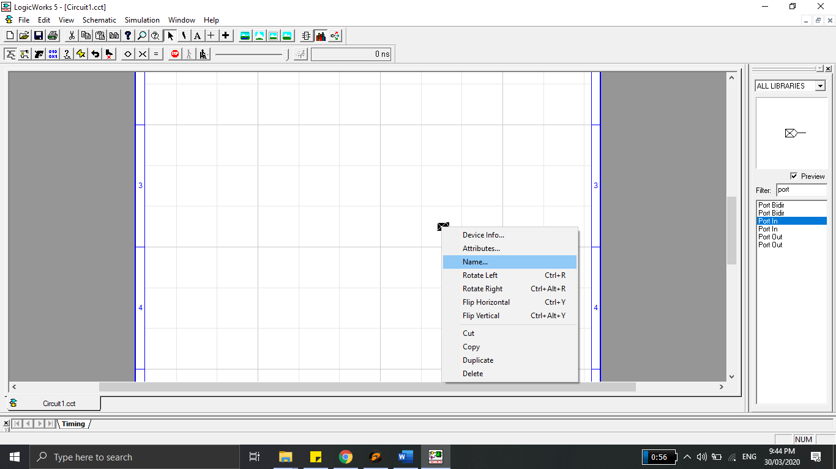

Every pin that will appear in the device symbol must be declared as a port in a sub-circuit. Once the ports are defined, all switches and clocks should be removed from the circuit pins.

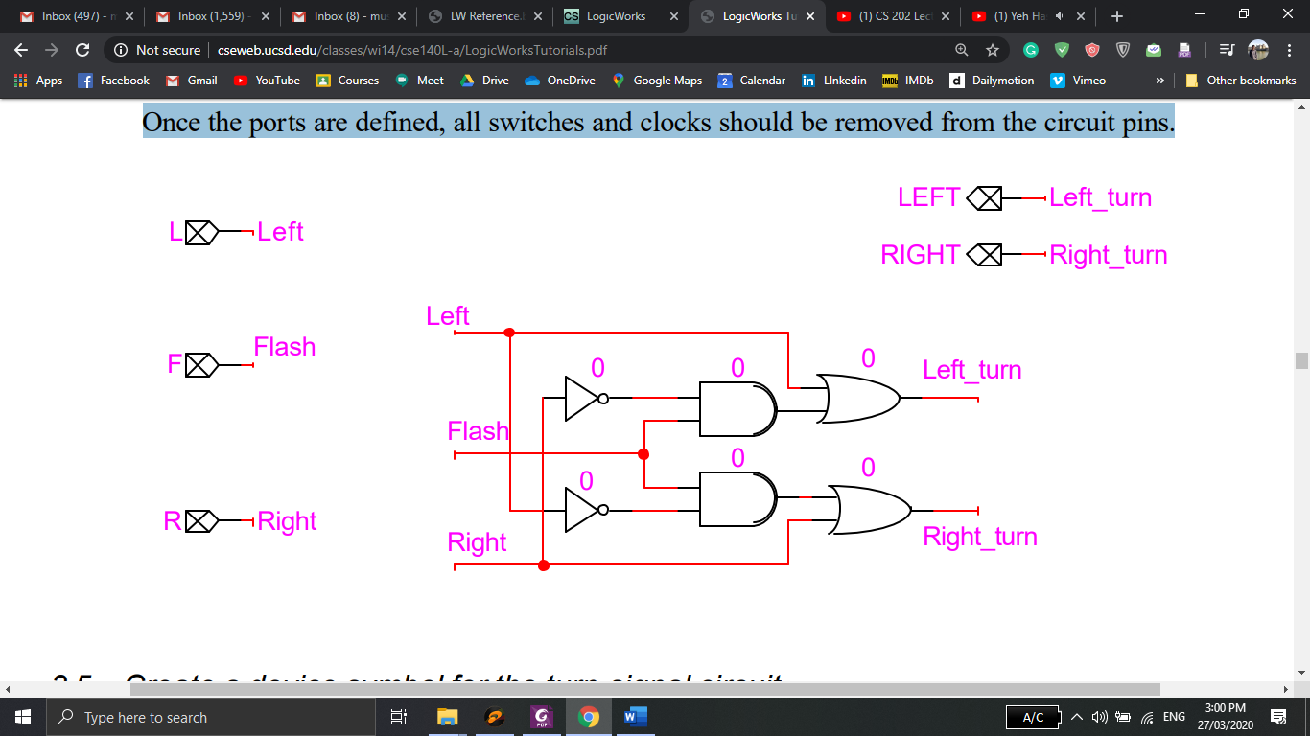

Step 3: Leave the turn-signal circuit open. Open a new file.

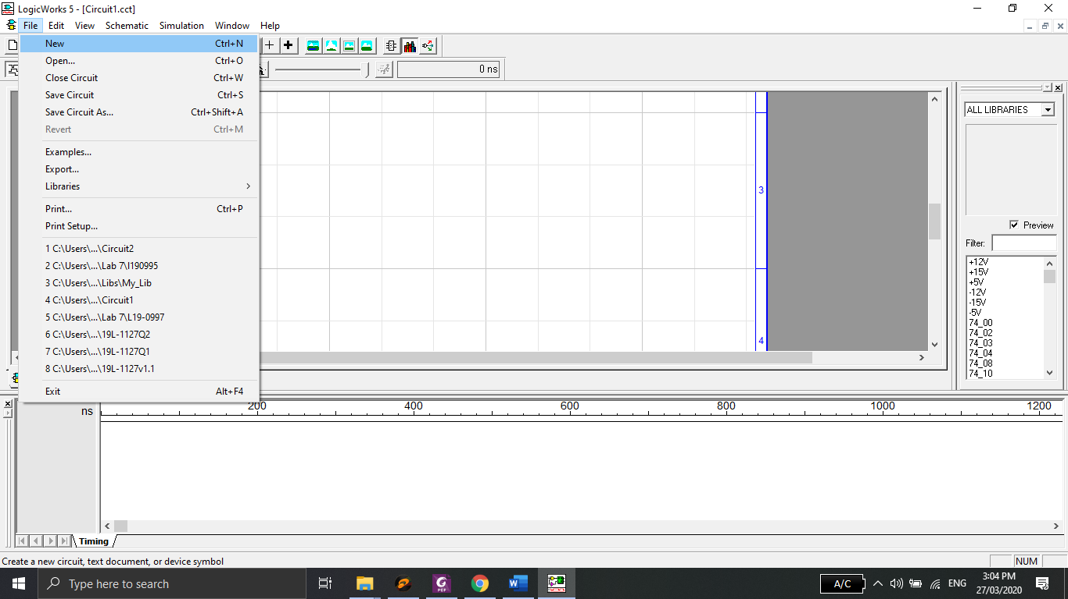

These options will appear: **Text document, Device Symbol, Model Wizard, VHDL** Choose **Device Symbol** and click OK.

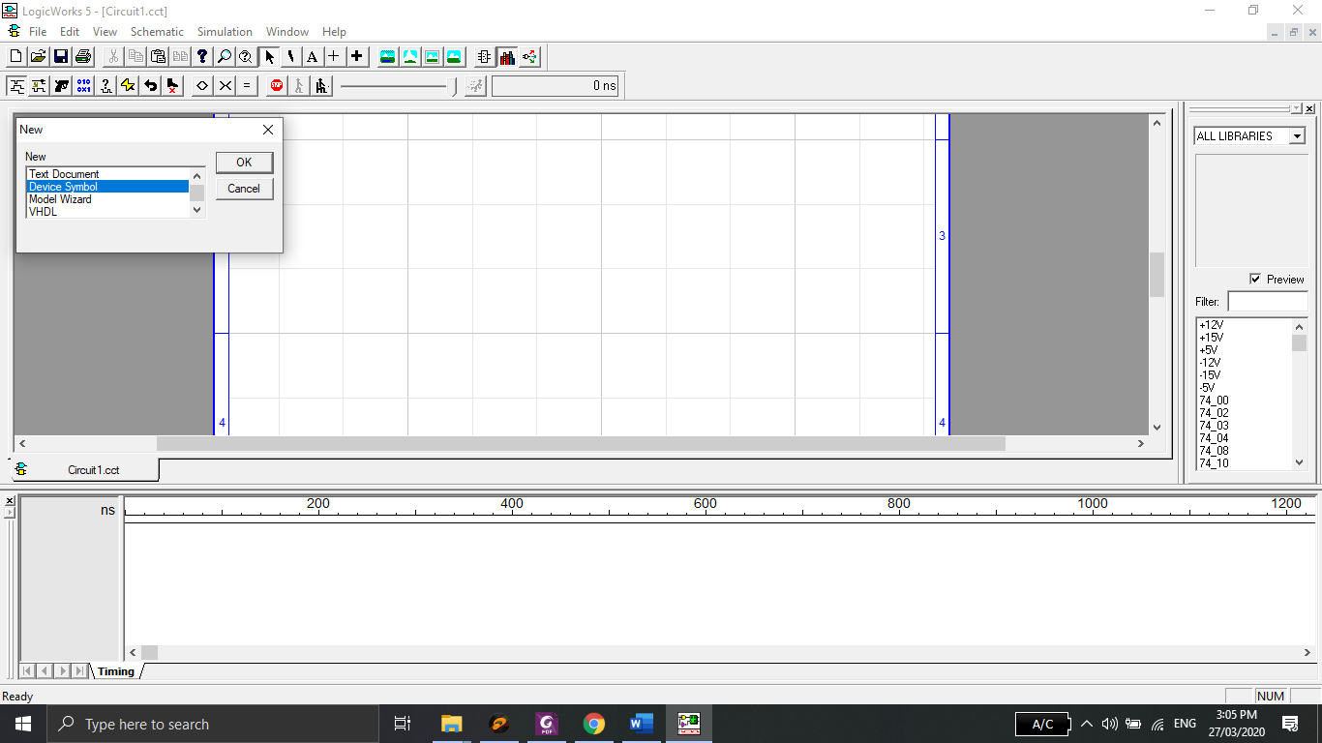

The device symbol editor is opened. In **Options** menu, select **Sub-circuit/Part Type** command.

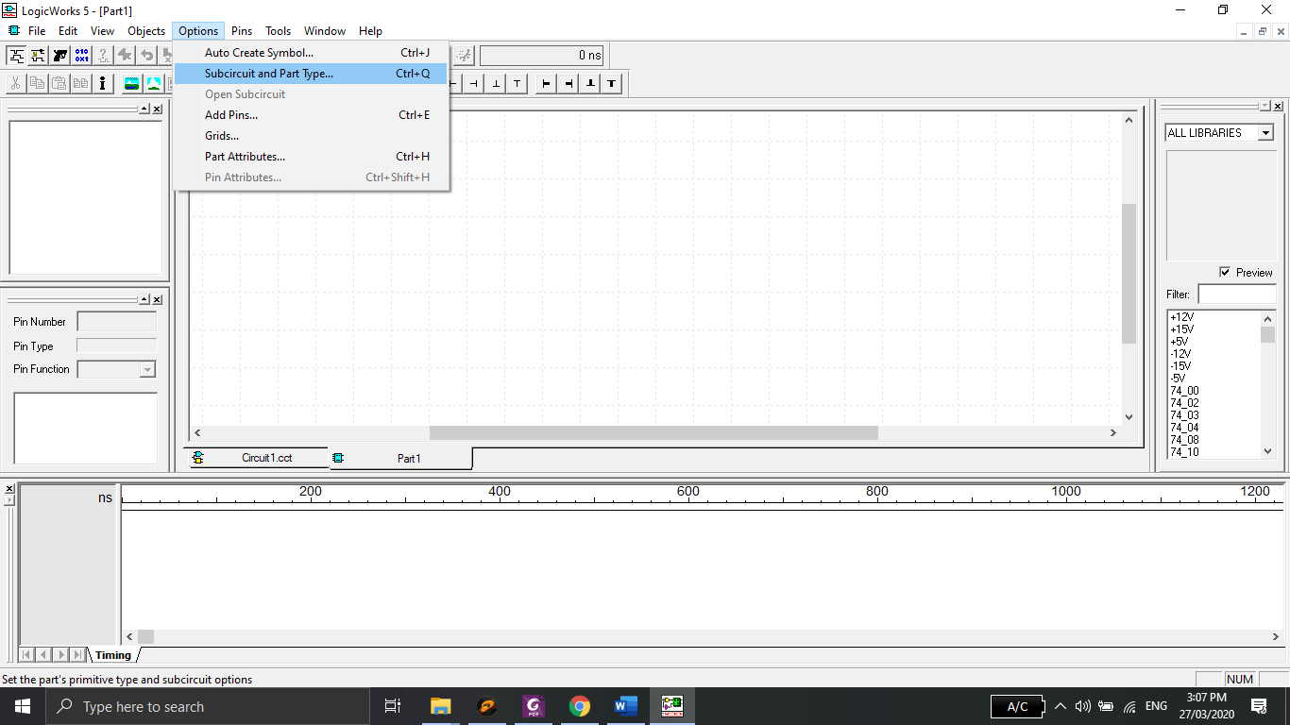

In Part Type, choose “Create a sub-circuit symbol and select an open circuit to attach to it.” When Select Internal Circuit dialog opens, click on the turn-signal sub-circuit. Click **OK** and then **Done**.

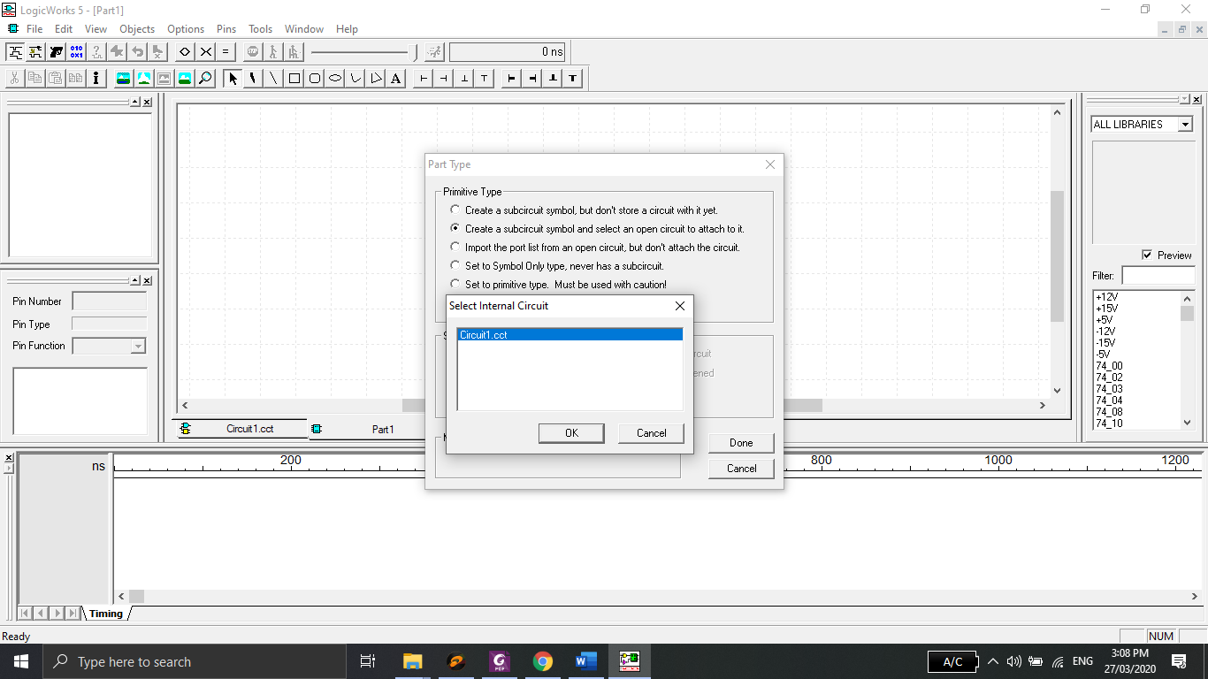

The symbol editor has extracted all port names from the port connectors in the sub-circuit and placed them in the Pin List at the left side of the device symbol window.

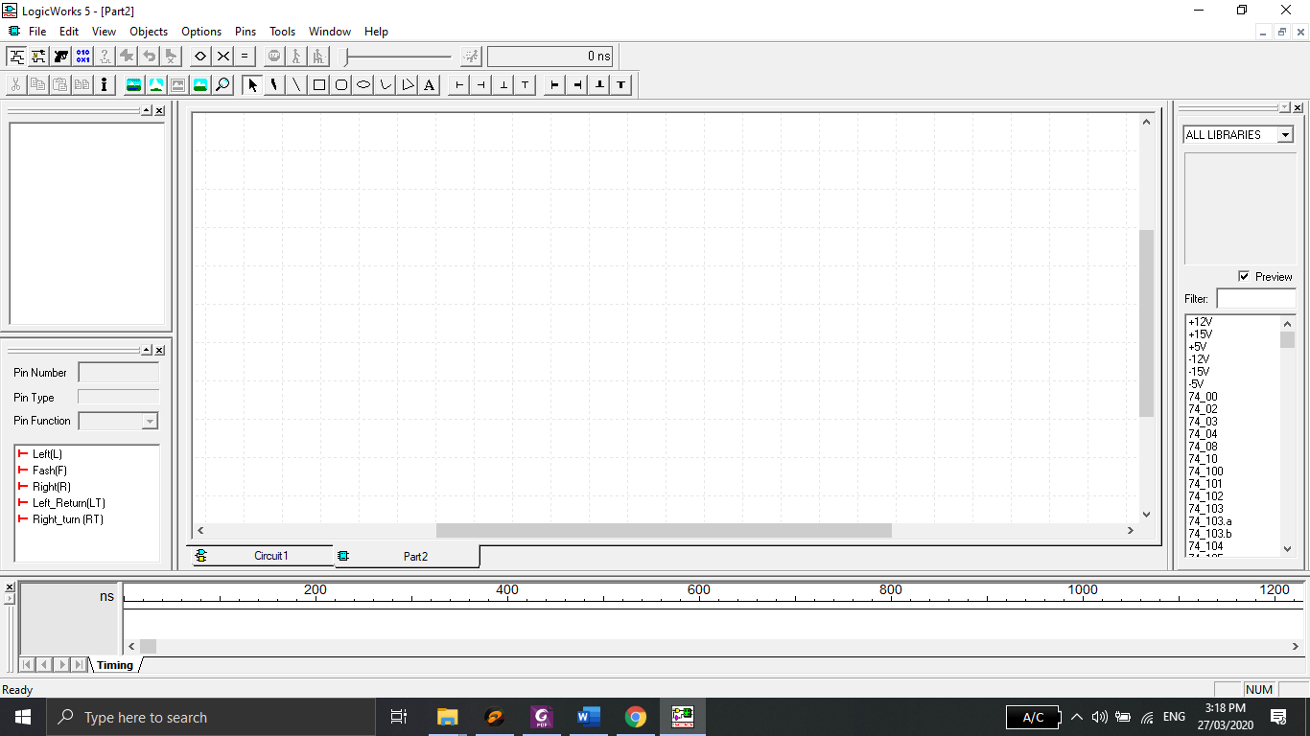

In **Options** menu, select **Auto Create Symbol**. This will bring up a dialogue box with five

fields for you to place text into.

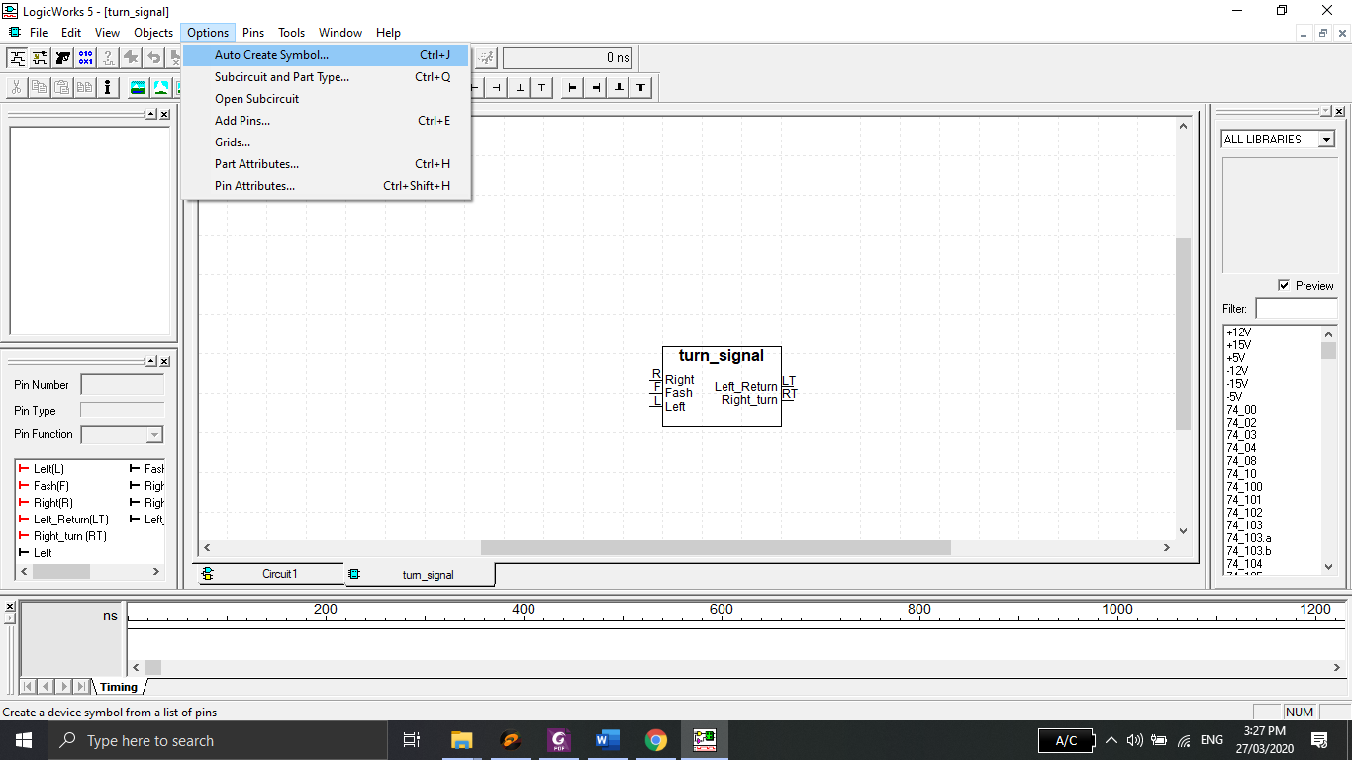

In the “Left Pins” field, type the names of the inputs. Separate pin names by spaces. DO NOT

HIT RETURN.

In the “Right Pins” field, type the names of the outputs.

Place the name you would like to call the symbol in the “Part Name” field in the middle of the

dialogue box.

Click on **Generate Symbol** and the symbol will be automatically generated for you.

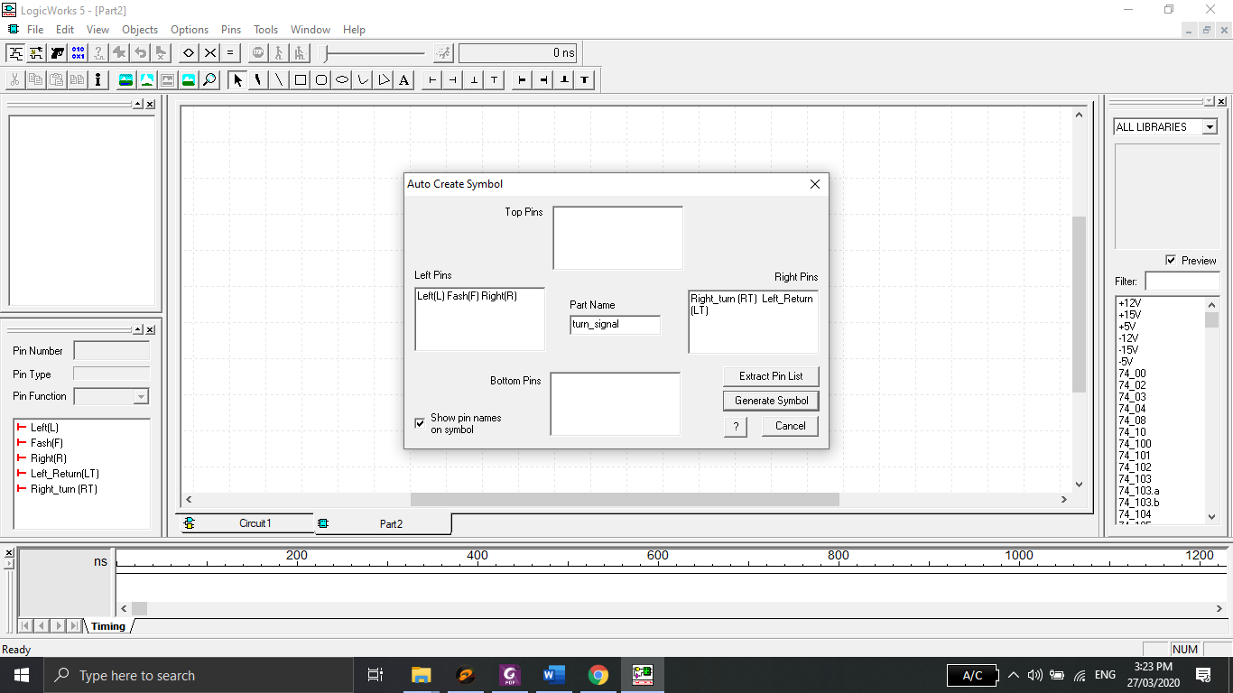

When you choose **Save** or **Save As** in **File** menu, you will be prompted to choose a library to save the symbol.

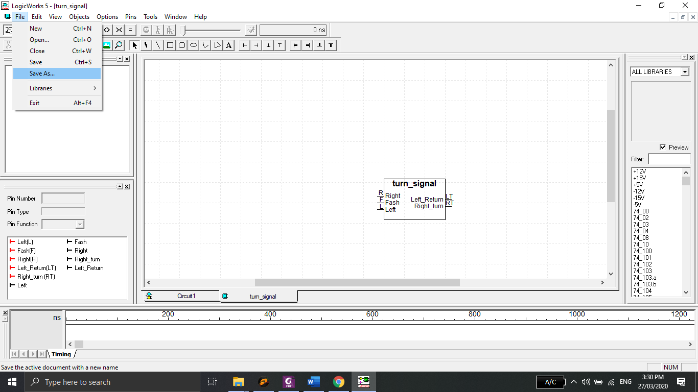

Click **New Library** button to create a new library. Name it **my_library** and save it in folder **LogicWorks 5.0\Libs**.

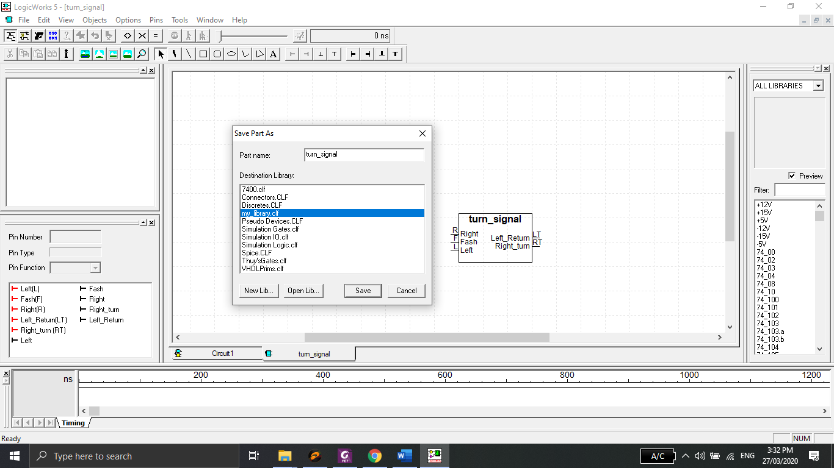

Name your symbol “turn_signal” as part name for this part and save it in **my_library.**

Step 4: Open a new design file. Get a component **turn_signal** from **my_library**.

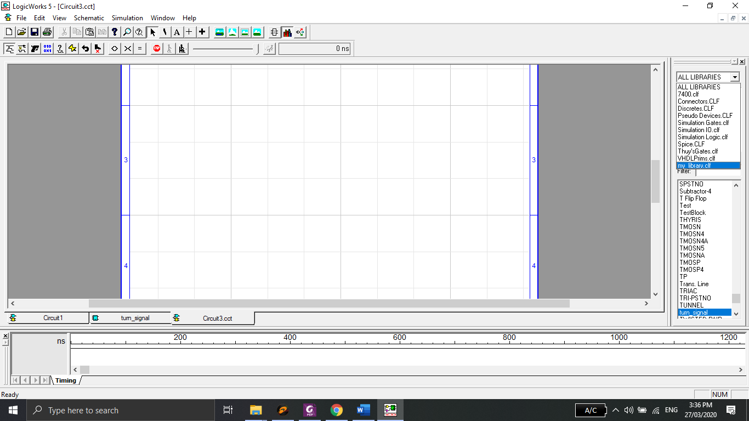

Add probes and binary switches to the outputs and inputs of the device as follows. Verify its functionality.

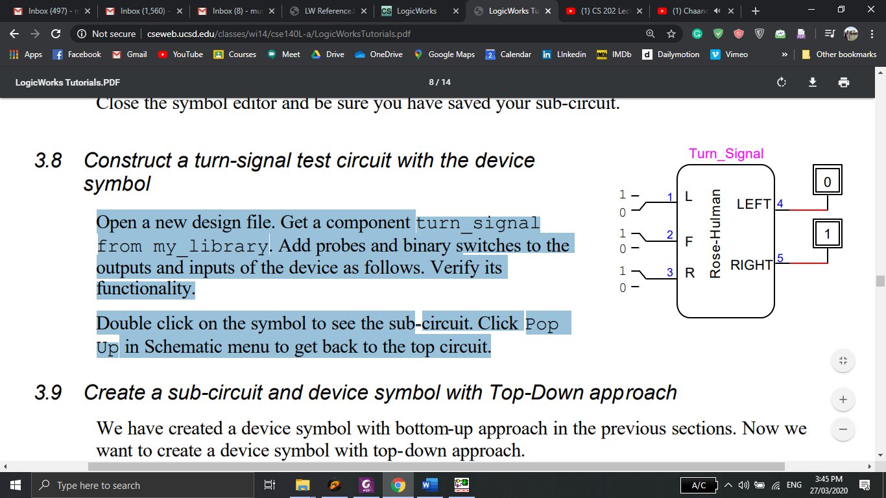

Double click on the symbol to see the sub-circuit. Click **Pop Up** in **Schematic** menu to get back to the top circuit.

## Problems / Assignments

|  |  |
| --- | --- |
| Problem 1 |  |

Implement the 4-bit adder subtractor circuit in LogicWorks. You must implement FA blocks as subcircuits in LogicWorks as explained above.

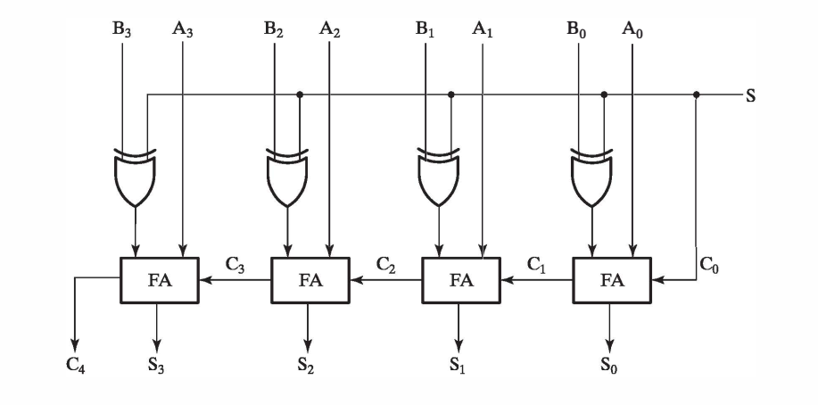

**Note: You just have to submit cct file. Please don’t submit clf file, generated in step 3.**